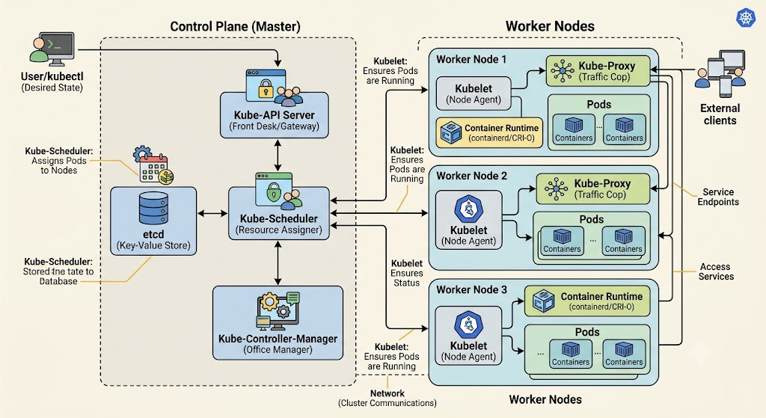
The Theoretical Workflow Breakdown
1. Initial Request & Initialization
- Step 1 (Submission): The user or administrator submits a deployment manifest (YAML/JSON file) using kubectl to request a change in the cluster's state.
- Step 2 (Authentication & Validation): The Kube-API Server intercepts the request, authenticates the user, validates the schema, and checks authorization permissions.
- Step 3 (First Storage): The API Server securely writes the new deployment configuration into etcd to update the intended "Source of Truth".
2. State Monitoring & Reconciliation
- Step 4 (Controller Notification): The Kube-Controller-Manager constantly watches the API Server for state changes. It intercepts the new deployment request from the API Server.
- Step 5 (Replica Set Generation): The Controller Manager creates the lower-level object (the ReplicaSet) to ensure the correct number of application copies are planned.
- Step 6 (Second Storage): The Controller Manager pushes this new instruction back to the API Server, which saves the ReplicaSet configuration inside etcd.
3. Scheduling & Assignment
- Step 7 (Scheduling Watch): The Kube-Scheduler actively monitors the API Server for newly created Pods that have a status of Pending and no assigned host.
- Step 8 (Node Evaluation & Binding): The Scheduler evaluates the cluster's resources, selects the optimal worker node for the Pods, and returns that assignment back to the API Server. The API Server writes this finalized binding node metadata directly back into etcd.
4. Actual Worker Execution
- Step 9 (Kubelet Execution): The Kubelet running on the targeted Worker Node regularly polls the API Server. It detects that a Pod has been assigned to its specific node ID.
- Step 10 (Container Launch): The Kubelet instructs the local Container Runtime (such as containerd or CRI-O) to pull the application container images and physically execute them.
- Step 11 (Status Reporting): Once the containers start running, the Kubelet reports the live health and execution status back to the API Server, completing the lifecycle reconciliation loop.

